***ANN Re entry securities @Europe***

Fake Exits

+ EWI

Perdida de la mmov 200 con VIX>30

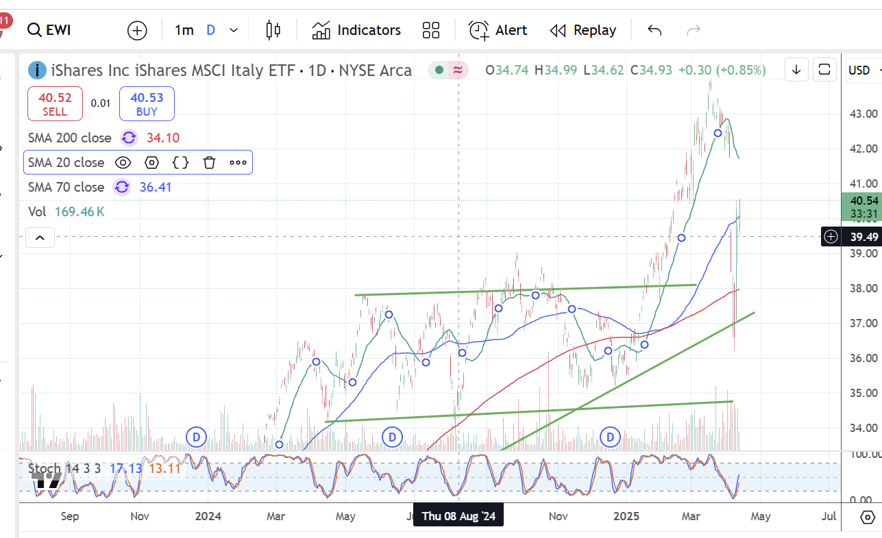

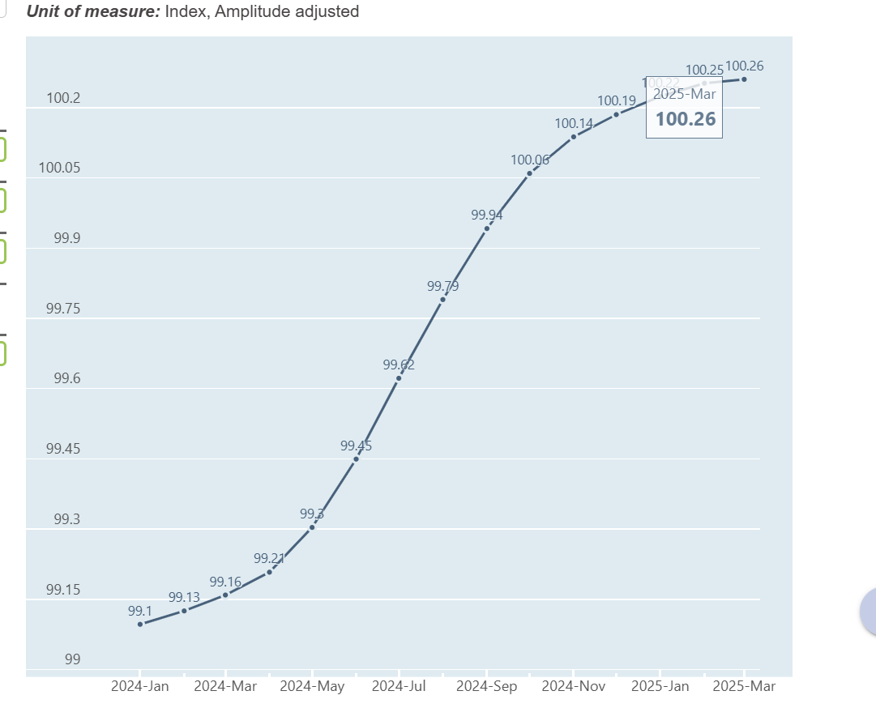

[https://data-explorer.oecd.org/vis?lc=en&vw=tl&df[ds]=dsDisseminateFinalDMZ&df[id]=DSD_STES%40DF_CLI&df[ag]=OECD.SDD.STES&dq=ITA.M.LI...AA...H&to[TIME_PERIOD]=false&pd=2024-01%2C](https://data-explorer.oecd.org/vis?lc=en&vw=tl&df%5bds%5d=dsDisseminateFinalDMZ&df%5bid%5d=DSD_STES%40DF_CLI&df%5bag%5d=OECD.SDD.STES&dq=ITA.M.LI...AA...H&to%5bTIME_PERIOD%5d=false&pd=2024-01%2C)

+ EWY 🡪 South Korea resists. LEI at best state

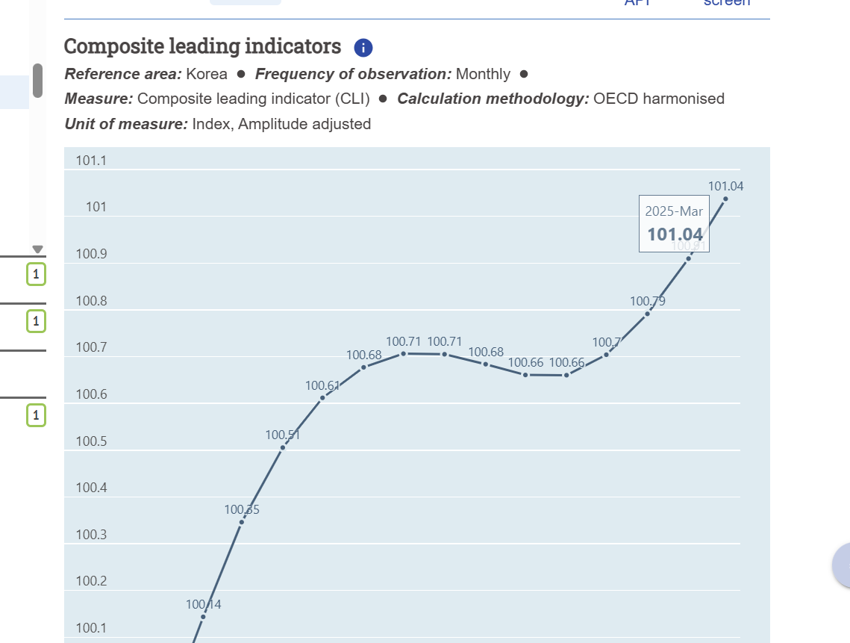

+ Major four European: VGK, FEZ

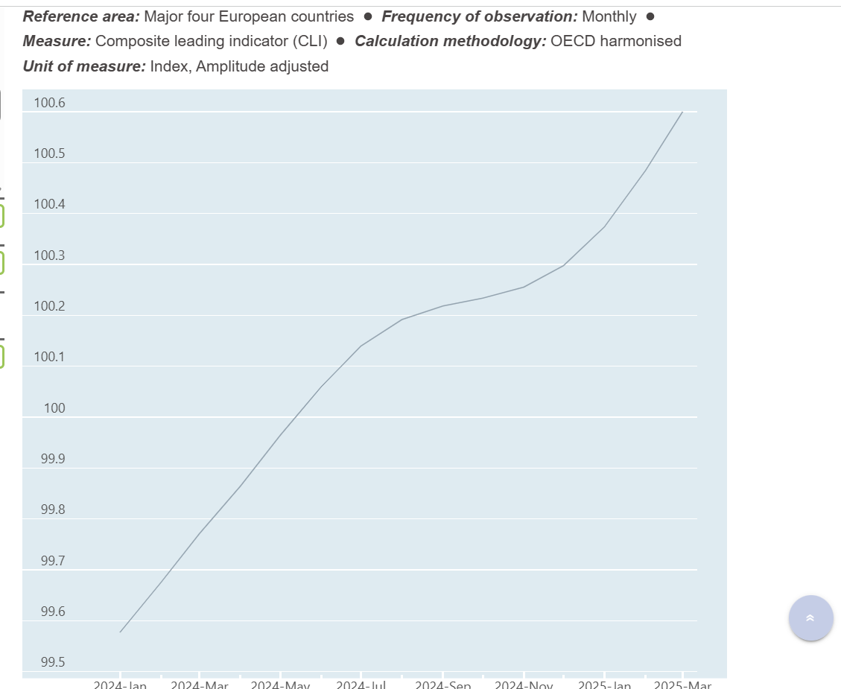

+ EWQ

